**Assignment 1**

**Create an infographic illustrating the test-driven development (TDD) process. highlight steps like writing tests before code benefits such as bug reduction and how it fosters software reliability.**

**Introduction**

Test-driven development, or TDD for short, is a software development process. As the name implies, involves utilizing tests to guide application development, resulting in simple, iterative implementation with good test coverage right from the start.

Test-Driven Designing and building tests for each single function of an application is the first step in development. Only when an automated test fails, the TDD framework tell developers to write new code. It prevents code duplication.

It is based on the simple principle of developing and correcting failed tests before writing new code (before development). We write a tiny piece of code at a time to pass tests, therefore it helps the developer to minimize duplicate code. Tests are nothing more than requirements that must be tested in order to be met.

It is a method of creating and executing automated tests prior to the application's real development. As a result, Test First Development is also known as TDD.

**Section 2: TDD Process**

1. Write a Test (Red Phase)

* Text: "Identify a new function or feature. Write a test that defines a specific goal for this function, which should initially fail."
* Icons:
  + A document with a pen writing on it
  + A red X indicating the test will fail initially

1. Run All Tests

* Text: "Run all tests to confirm the new test fails. This failure indicates the feature is not yet implemented."
* Icons:
  + A computer screen with a list of tests
  + An X symbol showing failure

1. Write Code (Green Phase)

* Text: "Write just enough code to make the test pass. The goal is minimal code implementation."
* Icons:
  + A keyboard or a coder at work
  + A green checkmark indicating the test now passes

1. Run Tests

* Text: "Run all tests again to ensure that the new code passes the new test without breaking any existing functionality."
* Icons:
  + A test running progress bar
  + Multiple green checkmarks

1. Refactor (Refactor Phase)

* Text: "Refactor the code to improve its structure and readability without changing its behavior. Run tests to ensure nothing breaks."
* Icons:
  + A wrench or a gear
  + A clean, organized code icon
  + Green checkmarks confirming tests still pass

1. Repeat

* Text: "Repeat the cycle for each new feature or improvement."
* Icons:
  + A circular arrow indicating repetition
  + A list getting progressively checked off

**Section 3: Benefits of TDD**

1. Bug Reduction

* Text: "Catch bugs early in the development process, minimizing costly fixes later."
* Icons:
  + A bug with a red slash through it
  + A magnifying glass spotting a bug

1. Enhance Reliability

* Text: "Ensure each part of the software works as expected, leading to more stable and reliable code."
* Icons:
  + A shield or a lock
  + A checkmark in a shield

1. Better Design

* Text: "Encourages simpler, more modular design by focusing on requirements first."
* Icons:
  + A blueprint or architectural plan
  + Puzzle pieces fitting together

1. Improved Documentation

* Text: "Tests serve as live documentation, showing how the system is supposed to behave."
* Icons:
  + A document with a checkmark
  + An open book

1. Confidence in Code

* Text: "Developers can refactor and enhance code with the assurance that tests will catch any errors introduced."
* Icons:
  + A developer with a confident expression
  + A thumbs-up

**Section 4: TDD Cycle Visualization**

Cycle Diagram:

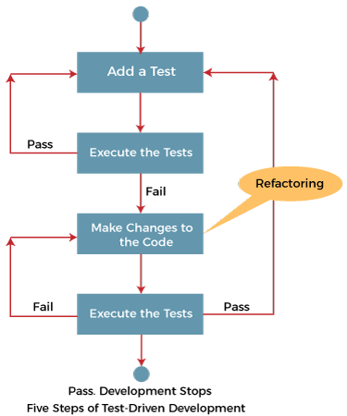

* Central large circle divided into three parts:
  + Write Test (Red):
    - Red segment with "Write Test" label and an X icon
* Write Code (Green):
  + Green segment with "Write Code" label and a checkmark icon
* Refactor (Refactor):
* Blue segment with "Refactor" label and a wrench icon
* Arrows: Curved arrows connecting the phases in a cycle.

**Section 5: Tips for Implementing TDD**

* Start Small
  + Text: "Begin with small, manageable features to gradually integrate TDD into your workflow."
    - Icons:
    - A small seedling growing
    - A small puzzle pieces
* Stay Disciplined
  + Text: "Stick to the Red-Green-Refactor cycle to maximize the benefits of TDD."
  + Icons:
    - A stopwatch or clock
    - A disciplined hand icon
* **Collaborate**
* Text: "Encourage team collaboration on writing and maintaining tests for better coverage and insights."
* Icons:
  + - Team of developers
    - Hands shaking or a team huddle

**Visual Elements**

* Color Scheme:
  + - Background: Light, neutral background to keep focus on the content.
    - Red Phase: Red for the "Write Test" phase.
    - Green Phase: Green for the "Write Code" phase.
    - Blue Phase: Blue for the "Refactor" phase.
* Icons:
  + - Consistent style, simple and clean to match the professional tone.
* Fonts:
  + - Headers: Bold, sans-serif for clarity and impact.
    - Body Text: Regular, sans-serif for readability.
* Graphics:
  + - Arrows: Smooth, curved arrows to indicate flow.
    - Icons: Clear and relevant to each section, ensuring visual consistency.

By following this detailed outline, the infographic will effectively communicate the TDD process and its benefits, providing a clear and informative guide for both novice and experienced developers.